**Tổng hợp code example**

**Example 1**

[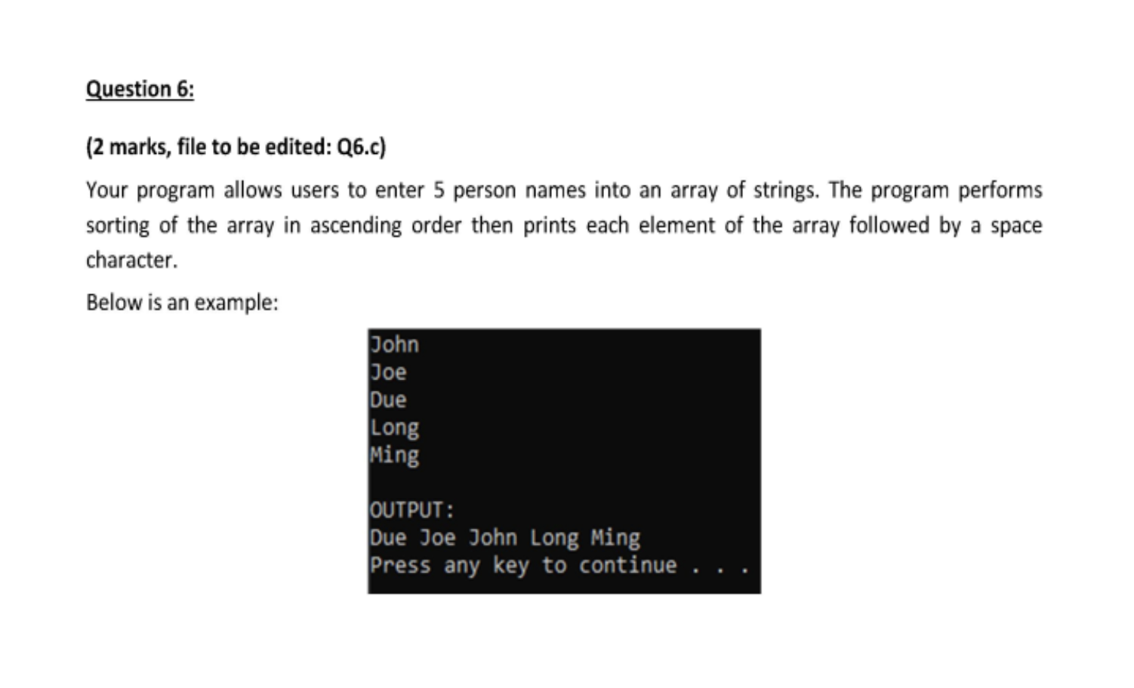](https://user-images.githubusercontent.com/29374426/179368107-7a322147-f799-4b9a-809a-e1cf4e1ea1ca.png)

#include <stdio.h>

char str[5][80], tmp[80];#include <stdlib.h>

#include <string.h>

#include <math.h>

int main()

{

system("cls");

// INPUT - @STUDENT:ADD YOUR CODE FOR INPUT HERE:

int i, j;

for (i = 0; i < 5; i++)

scanf("%s", str[i]);

// Fixed Do not edit anything here.

printf("\nOUTPUT:\n");

//@STUDENT: WRITE YOUR OUTPUT HERE:

for (i = 0; i < 4; i++)

{

for (j = i + 1; j < 5; j++)

{

if (strcmp(str[i], str[j]) > 0)

{

// ham cmp so sanh 2 chuoi

// uu tien alphabet

strcpy(tmp, str[i]);

strcpy(str[i], str[j]);

strcpy(str[j], tmp);

}

}

}

for (i = 0; i < 5; i++)

printf("%s ", str[i]);

//--FIXED PART - DO NOT EDIT ANY THINGS HERE

printf("\n");

system("pause");

return (0);

}

**Example 2**

[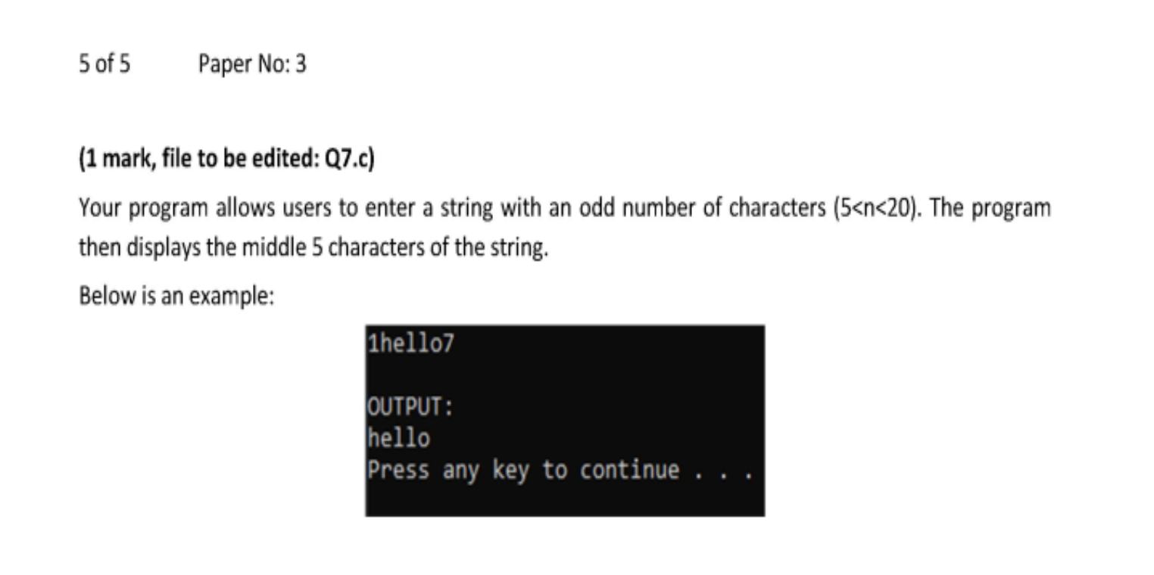](https://user-images.githubusercontent.com/29374426/179368118-66aa0e64-2609-4fc4-bdb4-7913a75c6a0d.png)

#include <stdio.h>

#include <stdlib.h>

#include <string.h>

#include <math.h>

int main()

{

system("cls");

// INPUT - @STUDENT:ADD YOUR CODE FOR INPUT HERE:

char str[100];

gets(str);

int j = strlen(str);

int i;

// Fixed Do not edit anything here.

printf("\nOUTPUT:\n");

//@STUDENT: WRITE YOUR OUTPUT HERE:

for (i = j / 2 - 2; i <= j / 2 + 2; i++)

{

printf("%c", str[i]);

}

//--FIXED PART - DO NOT EDIT ANY THINGS HERE

printf("\n");

system("pause");

return (0);

}

**Đảo ngược số**

//đảo ngược số

#include <stdio.h>

int reverse(int n)

{

int reNum = n % 10; // b1 láº¥y chá»¯ sá»‘ cuá»‘i cÃ¹ng

n /= 10; // bá»� chá»¯ sá»‘ cuá»‘i cÃ¹ng

int last;

while (n > 0)

{

last = n % 10; // láº¥y chá»¯ sá»‘ cuá»‘i cÃ¹ng

n /= 10; // bá»� chá»¯ sá»‘ cuá»‘i cÃ¹ng

reNum = reNum * 10 + last; // vÃ²ng láº·p Ä‘á»ƒ thá»±c hiá»‡n bÆ°á»›c 2 3 4

}

return reNum;

}

int main()

{

int n;

printf("INPUT NUMBER: ");

scanf("%d", &n);

printf("REVERSE NUMBER OF %d IS %d ", n, reverse(n));

return 0;

}

// armstrong

#include <stdio.h>

#include <math.h>

int countDigits(int num)

{

int count = 0;

while (num > 0)

{

num /= 10;

count++;

}

return count;

}

bool isArmstrong(int num)

{

int numDigit = countDigits(num);

int tmp = num;

int sum = 0;

int last;

while (tmp > 0)

{

last = tmp % 10;

tmp /= 10;

sum += pow(last, numDigit);

}

if (sum == num)

return true;

return false;

}

int main()

{

int num;

printf("input number: ");

scanf("%d", &num);

if (isArmstrong(num) == true)

{

printf("%d is Armstrong number.", num);

}

else

{

printf("%d is not Armstrong number.", num);

}

//getch();

}

**Example 3**

[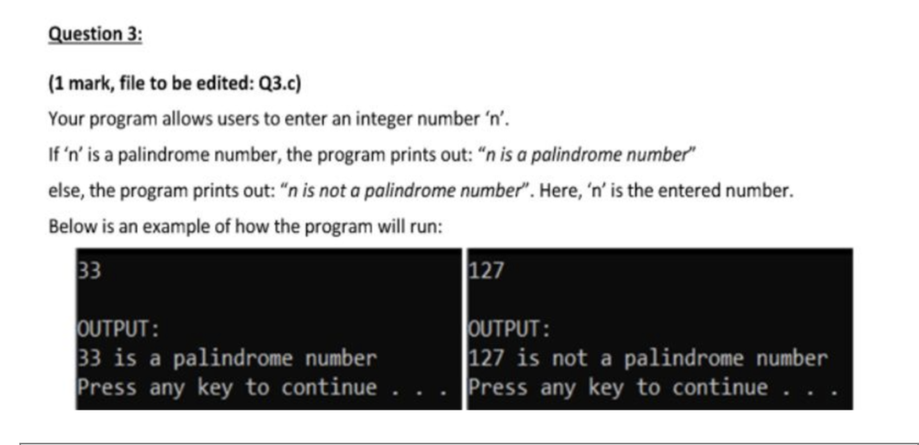](https://user-images.githubusercontent.com/29374426/179368427-23cc765f-3e42-4b4d-88ea-7d9ce1a7e64a.png)

#include <stdio.h>

int main()

{

int n, reversed = 0, remainder, original;

printf("Enter an integer: ");

scanf("%d", &n);

original = n;

// reversed integer is stored in reversed variable

while (n != 0 && n >= 0)

{

remainder = n % 10;

reversed = reversed * 10 + remainder;

n /= 10;

}

// palindrome if orignal and reversed are equal

// ve hinh tam giac can chieu dai 2 canh = n nhu vi du

//Vi du n=4

/*

*

**

***

****

***

**

*

*/

#include <stdio.h>

#include <stdlib.h>

#include <string.h>

#include <math.h>

#include <ctype.h>

int main() {

system("cls");

//INPUT - @STUDENT:ADD YOUR CODE FOR INPUT HERE:

int n;

scanf("%d", &n);

// Fixed Do not edit anything here.

printf("\nOUTPUT:\n");

//@STUDENT: WRITE YOUR OUTPUT HERE:

int i,j;

for(i = 0; i < 2*n - 1;i++) { //In cot dung de in 2*n so cot chua sao nhu n=4 thi co 8 cot chua sao

//Trong vong for nay dung de in hang

for(j = 0; j < n;j++) {//Trong 1 hang toi da la n sao

if(i >= n -1 - j && i <= n -1 +j)

/*i>= n -1 - j: Dieu kien in ra so sao hang phia duoi*/

/*i <= n -1 +j: Dieu kien in ra so sao o hang phia tren*/

printf("*");

else printf(" ");

}

}

printf("\n");

}

//--FIXED PART - DO NOT EDIT ANY THINGS HERE

printf("\n");

system ("pause");

return(0);

}

**Example 4**

Nhập vào số nguyên dương n và n số nguyên. Tìm số xuất hiện nhiều nhất

#include <stdio.h>

#include <stdlib.h>

#include <string.h>

#include <math.h>

#include <ctype.h>

int main() {

system("cls");

//INPUT - @STUDENT:ADD YOUR CODE FOR INPUT HERE:

int n;

int arr[1000], b[1000] = {0}, c[1000] = {0}; //Khoi tao 3 mang so nguyen

int i;

scanf("%d", &n); //Nhap so phan tu cua mang arr

for(i = 0; i < n;i++)

{

scanf("%d", &arr[i]); // Nhap n phan tu mang so nguyen arr

}

for(i = 0; i < n;i++)

{

if(arr[i] > 0) //Mang so nguyen b[] ghi lai so lan xuat hien cua

b[arr[i]]++; //cac phan tu lon hon 0 trong day arr

if(arr[i] < 0) //Mang so nguyen c[] ghi lai so lan xuat hien cua

c[-arr[i]]++; //cac phan tu nho hon 0 trong day arr

}

int max = 0;

for(i = 0; i <n ;i++)

{

if(arr[i] > 0)

{

if(b[arr[i]] > max)

max = b[arr[i]];

}

else

{

if(c[-arr[i]] > max)

max = c[-arr[i]];

}

}// Vong lap tra ra so lan xuat hien nhieu nhat cua mot phan tu trong arr

// Fixed Do not edit anything here.

printf("\nOUTPUT:\n");

//@STUDENT: WRITE YOUR OUTPUT HERE:

for(i = 0; i <1000 ;i++)

{

if(b[i] == max)

{

printf("%d", i);

}

if(c[i] == max)

printf("%d", -i);

} //In ra phan tu co lan xuat hien nhieu nhat trong day

//--FIXED PART - DO NOT EDIT ANY THINGS HERE

printf("\n");

system ("pause");

return(0);

}

**Example 5**

Tính tổng sum = 1/x + 1/x^2 + 1/x^3 +... + 1/x^n Với x và n là số nguyên nhập từ bàn phím

#include <stdio.h>

#include <stdlib.h>

#include <string.h>

#include <math.h>

#include <ctype.h>

int main() {

system("cls");

//INPUT - @STUDENT:ADD YOUR CODE FOR INPUT HERE:

int x,n;

scanf("%d%d", &x, &n); //Nhap vao hai so nguyen x va n

double sum = 0; //Khoi tao gia tri cua tong bang khong

int i;

for(i = 0;i <= n;i++)

{

sum+= 1 / (pow(x,i)); //pow(x,i) la ham tinh luy thua bac i cua x

}

// Fixed Do not edit anything here.

printf("\nOUTPUT:\n");

//@STUDENT: WRITE YOUR OUTPUT HERE:

printf("%.2lf\n", sum);

//--FIXED PART - DO NOT EDIT ANY THINGS HERE

printf("\n");

system ("pause");

return(0);

}

// nhap vao mot chuoi bat ki, xoa het cac ki tu và so, chi giu lai cac chu cai

#include <stdio.h>

#include <stdlib.h>

#include <string.h>

#include <math.h>

#include <ctype.h>

#include <stdbool.h>

int main() {

system("cls");

//INPUT - @STUDENT:ADD YOUR CODE FOR INPUT HERE:

char str[100];

scanf("%[^\n]", str);

int i,j;

bool all_al = false;

while(all_al == false) // lap de xoa ki tu khong phai chu cai

{

all_al = true;

for(i = 0; i < strlen(str);i++)

{

if(!isalpha(str[i])) // kiem tra xem str[i] co phai la chu cai khong

{

for(j = i; j < strlen(str) ; j++) // xoa str[i] neu str[i] khong phai chu cai

{

str[j] = str[ j + 1];

}

}

}

for( i = 0; i < strlen(str);i++) // kiem tra trong str co ki tu nao khong phai chu cai khong

{

if(!isalpha(str[i]))

all_al = false;

}

}

// Fixed Do not edit anything here.

printf("\nOUTPUT:\n");

//@STUDENT: WRITE YOUR OUTPUT HERE:

printf("%s\n", str);

//--FIXED PART - DO NOT EDIT ANY THINGS HERE

printf("\n");

system ("pause");

return(0);

}

//nhap vao mot so tu nhien n, in ra 4 so nguyen to gan nhat lon hon n

#include <stdio.h>

#include <stdlib.h>

#include <string.h>

#include <math.h>

#include <ctype.h>

#include <stdbool.h>

bool isPrime(int n) // ham kiem tra so nguyen to

{

if( n < 2)

return false;

int i;

for(i = 2; i <= sqrt(n);i++)

{

if(n % i == 0)

return false;

}

return true;

}

int main() {

system("cls");

//INPUT - @STUDENT:ADD YOUR CODE FOR INPUT HERE:

int count = 4;

int n;

scanf("%d", &n);

int i = 1;

// Fixed Do not edit anything here.

printf("\nOUTPUT:\n");

//@STUDENT: WRITE YOUR OUTPUT HERE:

while(count > 0) // in ra 4 so nguyen to lon hon n

{

if(isPrime(n + i))

{

printf("%d\n", n + i);

count--;

}

i++;

}

//--FIXED PART - DO NOT EDIT ANY THINGS HERE

system ("pause");

return(0);

}

**Example 6**

[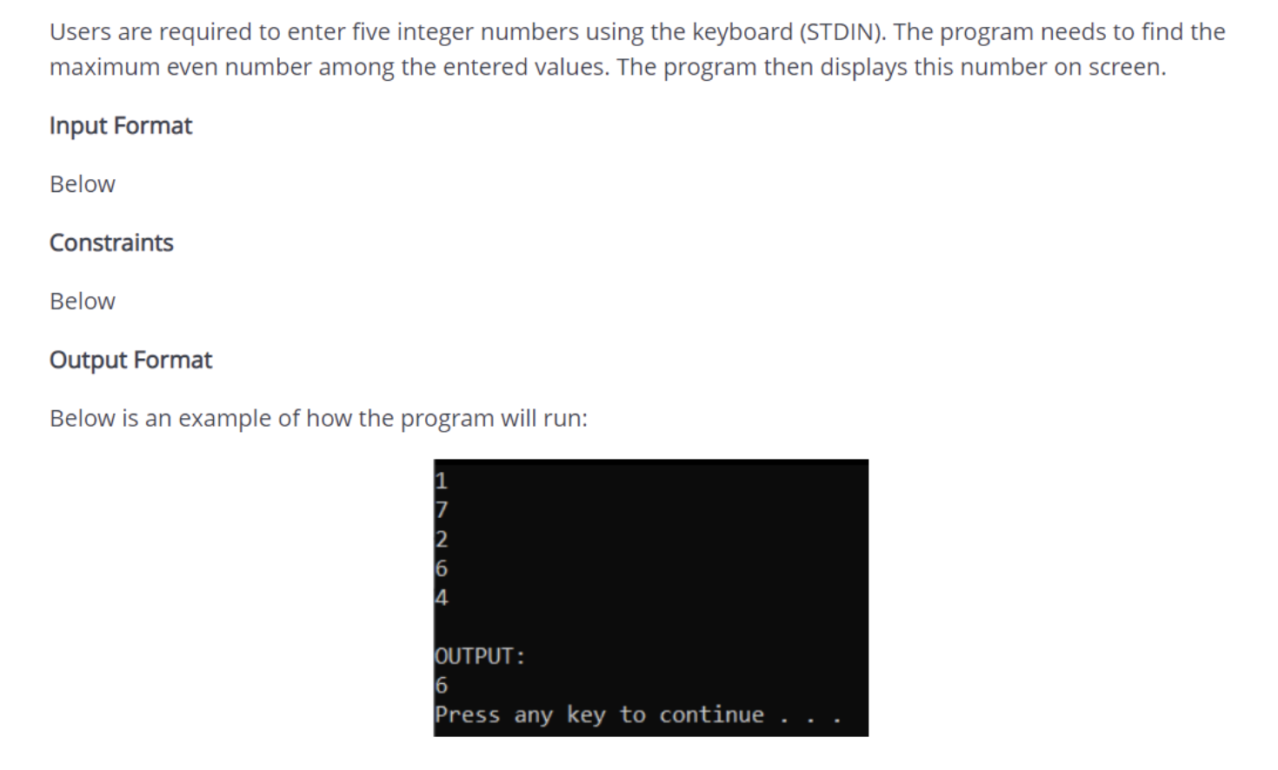](https://user-images.githubusercontent.com/29374426/179382380-6c959254-4619-4781-94d3-d93002b240c8.png)

#include <stdio.h>

#include <stdlib.h>

#include <string.h>

#include <math.h>

int sochan_max(int a[], int n)

{

int max;

int i = 0;

while (a[i] % 2 != 0)

i++;

max = a[i];

for (int j = i + 1; j < n; j++)

if (a[j] % 2 == 0)

if (max < a[j])

max = a[j];

return max;

}

int main()

{

system("cls");

// INPUT - @STUDENT:ADD YOUR CODE FOR INPUT HERE:

int arr[5];

for (int i = 0; i < 5; i++)

{

scanf("%d", &arr[i]);

}

// Fixed Do not edit anything here.

printf("\nOUTPUT:\n");

//@STUDENT: WRITE YOUR OUTPUT HERE:

printf("%d", sochan_max(arr, 5));

//--FIXED PART - DO NOT EDIT ANY THINGS HERE

printf("\n");

system("pause");

return (0);

}

**Example 7**

[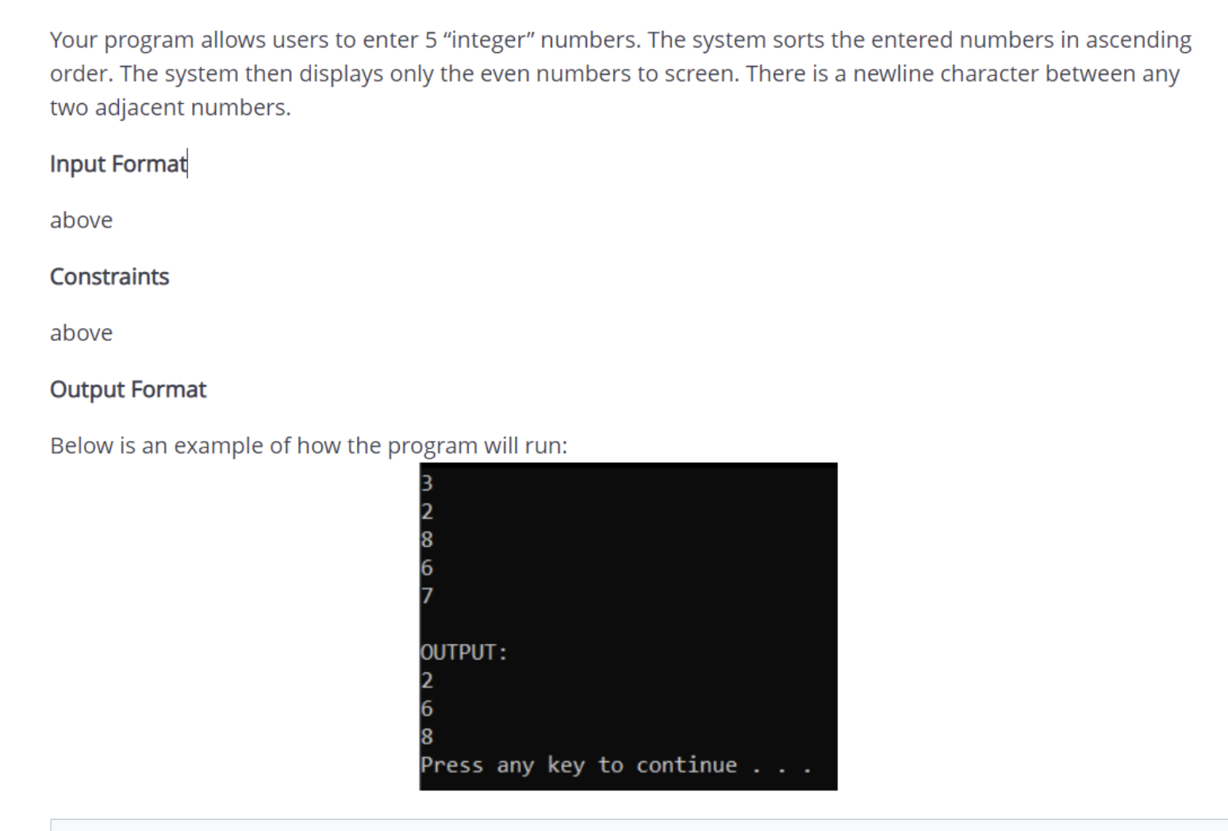](https://user-images.githubusercontent.com/29374426/179382390-7611ddc3-fc17-42b0-88e5-326fd542f61a.png)

#include <stdio.h>

#include <stdlib.h>

#include <string.h>

#include <math.h>

int main()

{

// system("cls");

// INPUT - @STUDENT:ADD YOUR CODE FOR INPUT HERE:

int arr[5];

int i, j;

for (i = 0; i < 5; i++)

{

scanf("%d", &arr[i]);

}

// Fixed Do not edit anything here.

printf("OUTPUT:\n");

//@STUDENT: WRITE YOUR OUTPUT HERE:

for (i = 0; i < 5; i++)

{

for (j = 4; j > i; j--)

{

if (arr[j] < arr[j - 1])

{

int tmp = arr[j];

arr[j] = arr[j - 1];

arr[j - 1] = tmp;

}

}

}

for (i = 0; i < 5; i++)

{

if (arr[i] % 2 == 0)

{

printf("%d\n", arr[i]);

}

}

}

**Example 8**

[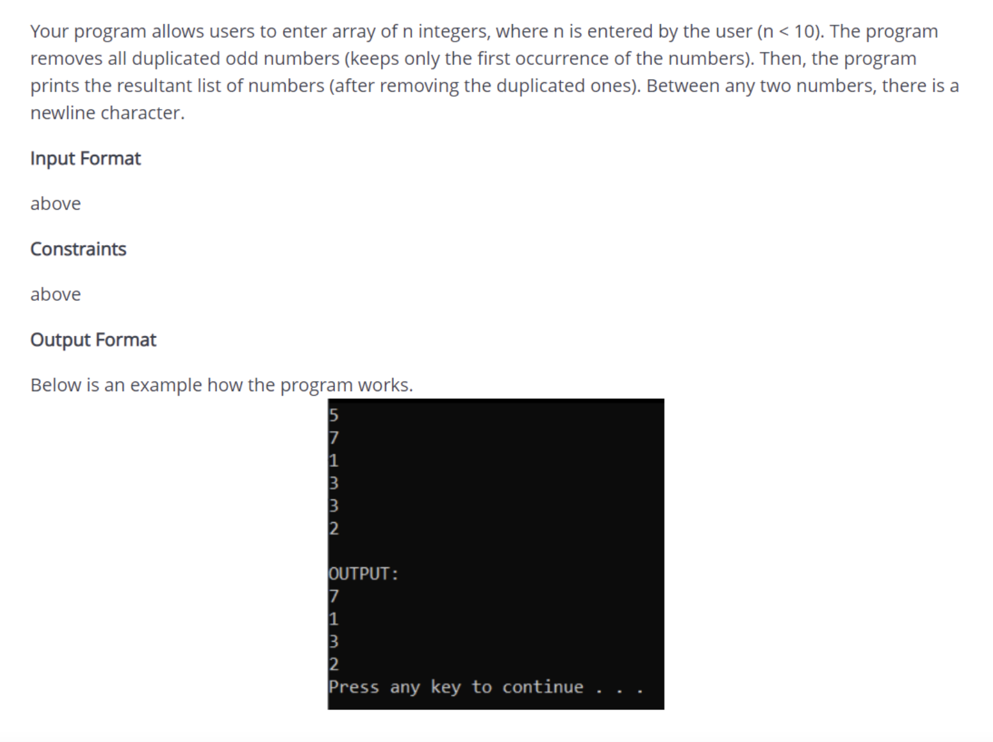](https://user-images.githubusercontent.com/29374426/179382400-dad6f566-8476-4eee-8a5f-c39e9c2931cf.png)

#include <stdio.h>

#include <stdlib.h>

#include <string.h>

#include <math.h>

int main()

{

system("cls");

// INPUT - @STUDENT:ADD YOUR CODE FOR INPUT HERE:

int n, arr[10], i, check = 0, j, k;

scanf("%d", &n);

for (i = 0; i < n; i++)

{

scanf("%d", &arr[i]);

}

for (i = 0; i < n - 1; i++)

{

for (j = i + 1; j < n; j++)

{

if (arr[i] == arr[j] && arr[i] % 2 != 0)

{

for (k = j; k < n; k++)

{

arr[k] = arr[k + 1];

}

n--;

j--;

}

}

}

// Fixed Do not edit anything here.

printf("OUTPUT:\n");

//@STUDENT: WRITE YOUR OUTPUT HERE:

for (i = 0; i < n; i++)

{

if (check == 0)

check = 1;

else

printf("\n");

printf("%d", arr[i]);

}

//--FIXED PART - DO NOT EDIT ANY THINGS HERE

printf("\n");

system("pause");

return (0);

}

**Example 9**

[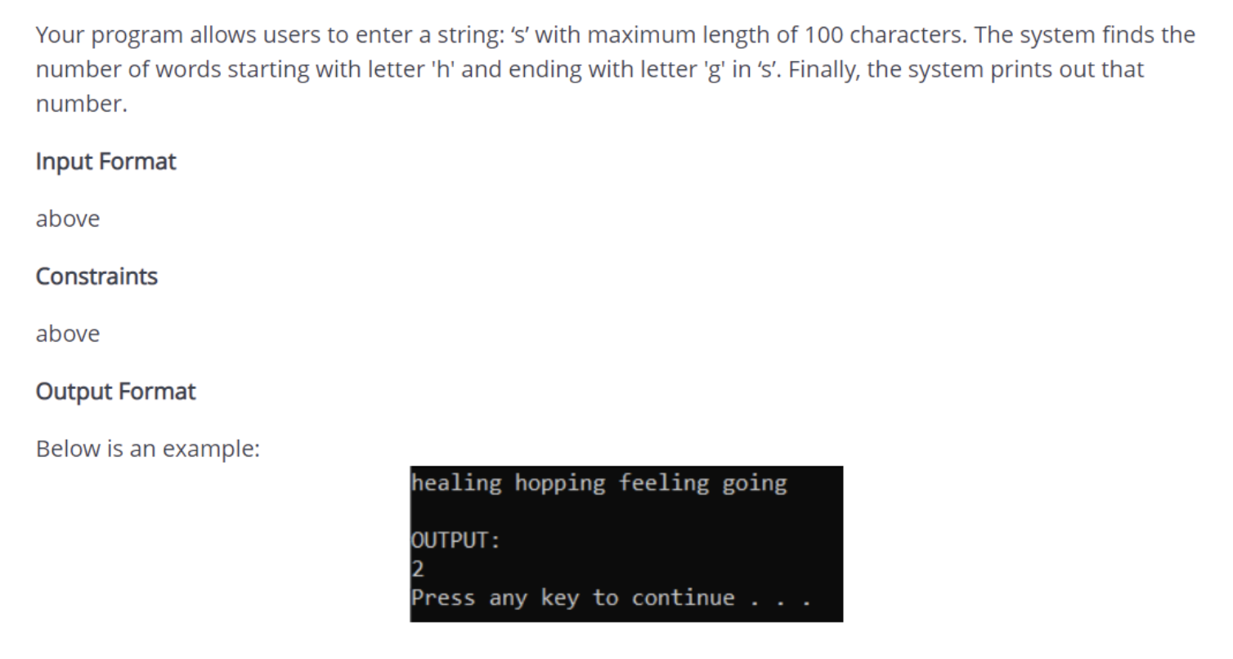](https://user-images.githubusercontent.com/29374426/179382522-110268c1-4331-47c5-85c4-f79516be8ab2.png)

#include <stdio.h>

#include <string.h>

int main()

{

system("cls");

// INPUT - @STUDENT:ADD YOUR CODE FOR INPUT HERE:

char s[100];

gets(s);

int i, j, count = 0;

char tmp[50][50];

for (i = 0; i < strlen(s); i++)

{

j = 0;

while (s[i] != ' ' && s[i] != '\0')

{

tmp[count][j] = s[i];

j++;

i++;

}

tmp[count][j] = '\0';

if (tmp[count][0] == 'h' && tmp[count][j - 1] == 'g')

count++;

}

// Fixed Do not edit anything here.

printf("\nOUTPUT:\n");

//@STUDENT: WRITE YOUR OUTPUT HERE:

printf("%d", count);

//--FIXED PART - DO NOT EDIT ANY THINGS HERE

printf("\n");

system("pause");

return (0);

}

**Example 10**

[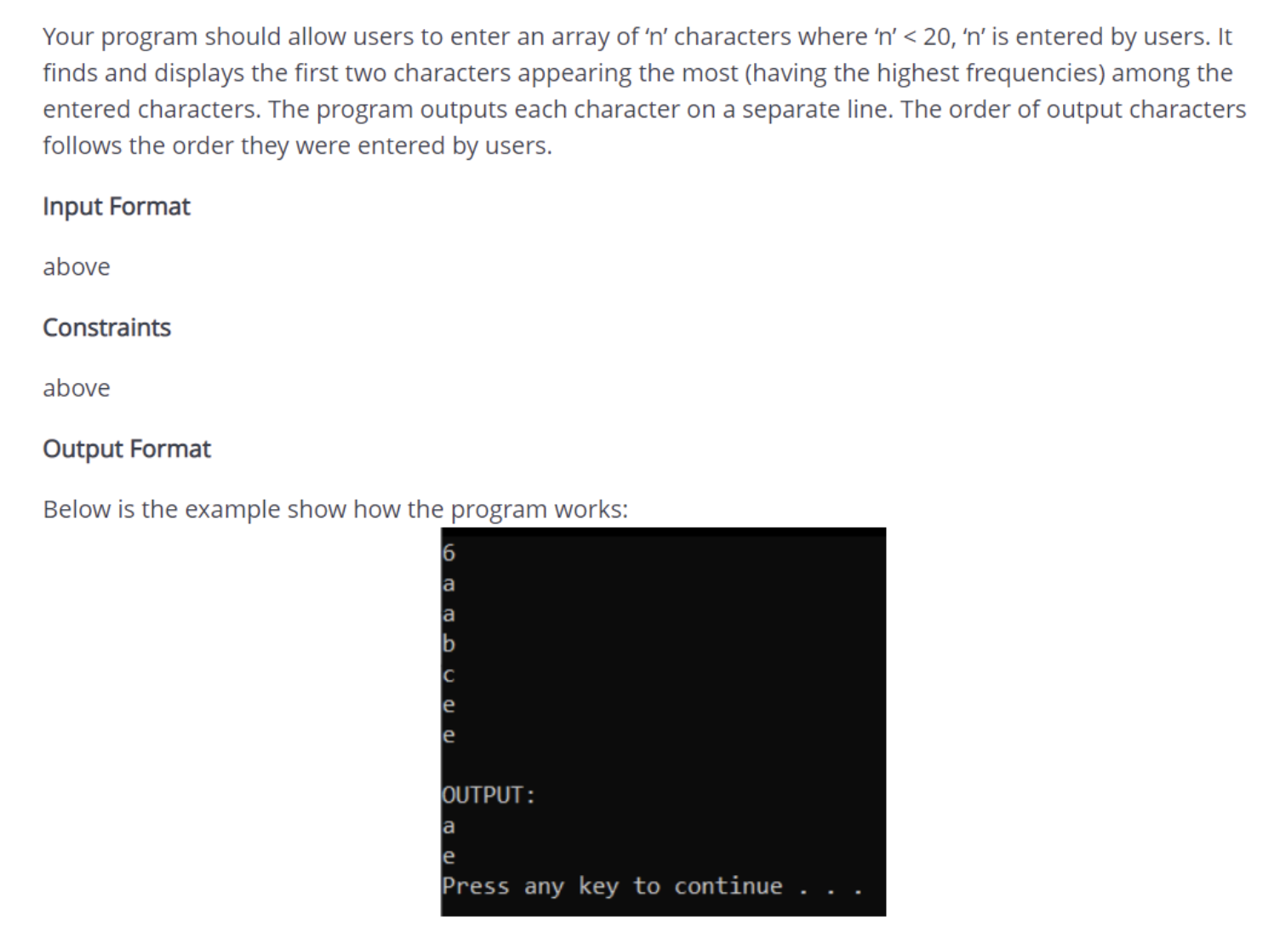](https://user-images.githubusercontent.com/29374426/179382513-92c3875a-110b-4abb-96b4-aaa3f1d67697.png)

#include <stdio.h>

#include <stdlib.h>

#include <string.h>

#include <math.h>

int main() ,

{

system("cls");

// INPUT - @STUDENT:ADD YOUR CODE FOR INPUT HERE:

int n, i, str[21], j, k, count = 0;

char c[21];

scanf("%d ", &n);

for (i = 0; i < n; i++)

{

scanf("%c", &c[i]);

getchar();

}

// Fixed Do not edit anything here.

printf("OUTPUT:\n");

//@STUDENT: WRITE YOUR OUTPUT HERE:

for (i = 0; i < n; i++)

{

str[i] = 1;

for (j = 0; j < n + 1; j++)

{

if (i != j)

{

if (c[i] == c[j])

{

str[i]++;

for (k = j; k < n; k++)

c[k] = c[k + 1];

n--;

j--;

}

}

}

}

for (i = 0; i < n; i++)

{

if (str[i] >= 2)

{

printf("%c", c[i]);

if (count != 1)

printf("\n");

count++;

if (count == 2)

break;

}

}

//--FIXED PART - DO NOT EDIT ANY THINGS HERE

printf("\n");

system("pause");

return (0);

}

**Example 11**

[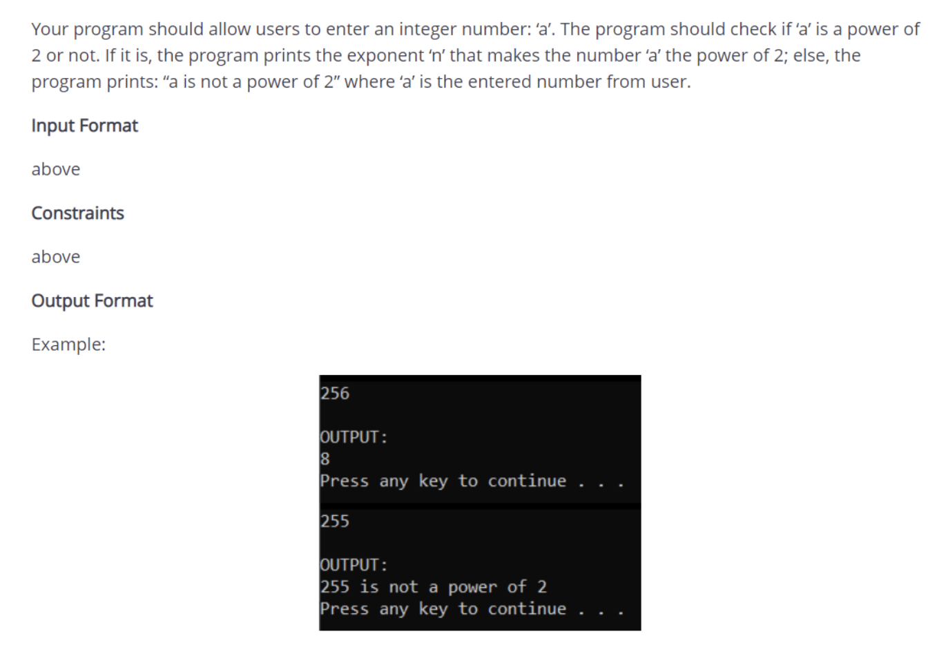](https://user-images.githubusercontent.com/29374426/179382502-08dca9df-db8a-4cf0-90d5-4a608f60ae12.png)

#include <stdio.h>

#include <stdlib.h>

#include <string.h>

#include <math.h>

int main()

{

system("cls");

// INPUT - @STUDENT:ADD YOUR CODE FOR INPUT HERE:

int a, tmp, flag = 0;

scanf("%d", &a);

tmp = a;

while (a % 2 == 0)

{

a /= 2;

flag++;

}

// Fixed Do not edit anything here.

printf("OUTPUT:\n");

//@STUDENT: WRITE YOUR OUTPUT HERE:

if (a == 1)

{

printf("%d", flag);

}

else

{

printf("%d is not a power of 2", tmp);

}

//--FIXED PART - DO NOT EDIT ANY THINGS HERE

printf("\n");

system("pause");

return (0);

}

**Example 12**

[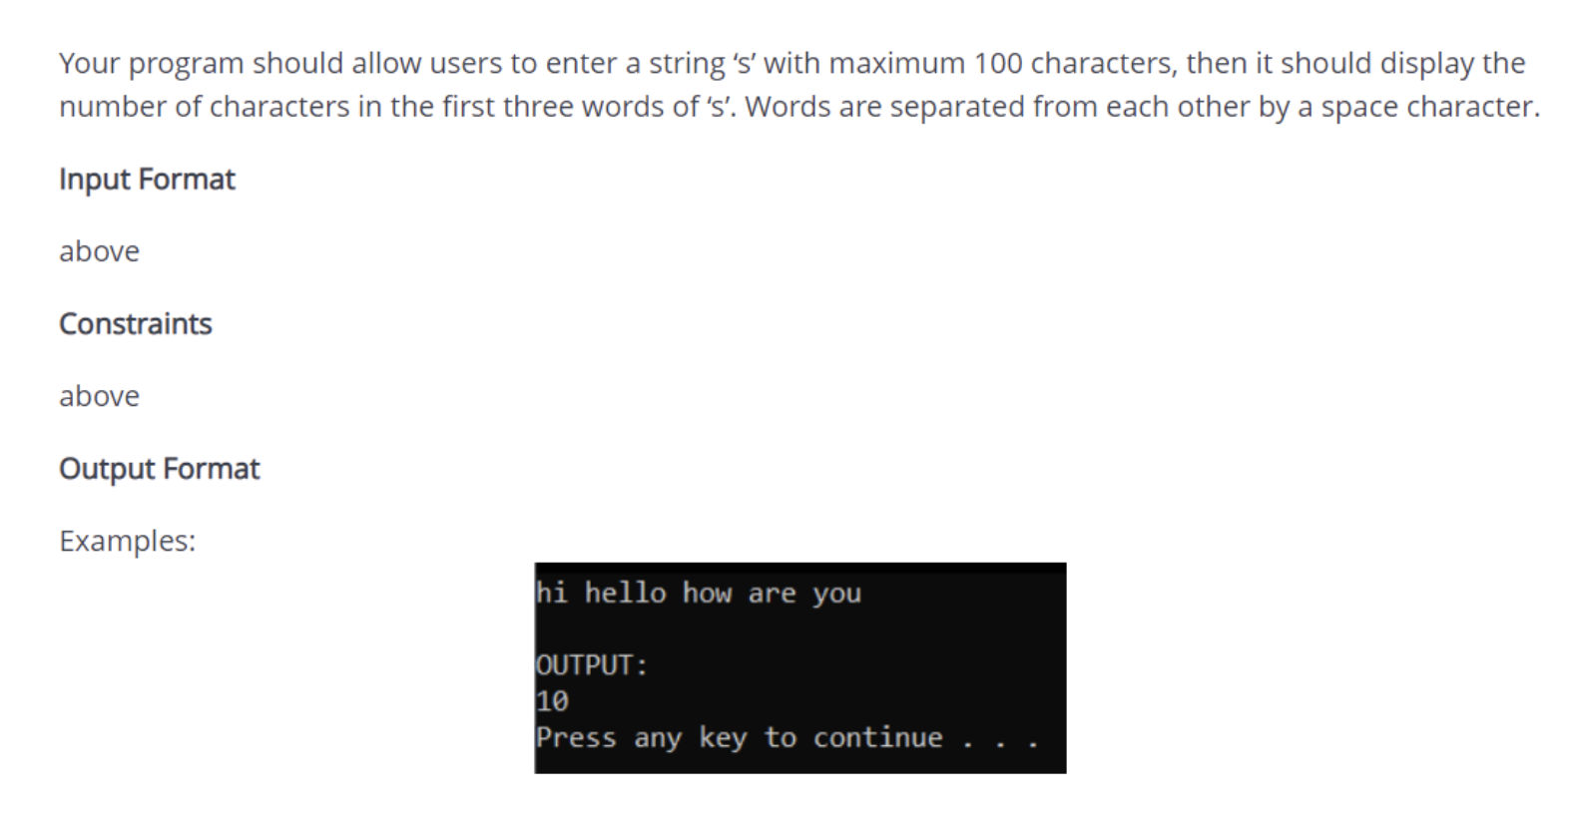](https://user-images.githubusercontent.com/29374426/179382495-1a796d0a-23b0-4f2a-837c-63e15769e099.png)

#include <stdio.h>

#include <stdlib.h>

#include <string.h>

#include <math.h>

int main()

{

system("cls");

// INPUT - @STUDENT:ADD YOUR CODE FOR INPUT HERE:

char s[100];

int i, count = 0, tmp = 0;

gets(s);

// Fixed Do not edit anything here.

printf("OUTPUT:\n");

//@STUDENT: WRITE YOUR OUTPUT HERE:

for (i = 0; i < strlen(s); i++)

{

if (s[i] != ' ' && tmp < 3)

{

while (s[i] != ' ')

{

count++;

++i;

;

}

tmp++;

}

}

printf("%d", count);

//--FIXED PART - DO NOT EDIT ANY THINGS HERE

printf("\n");

system("pause");

return (0);

}

**Example 13**

[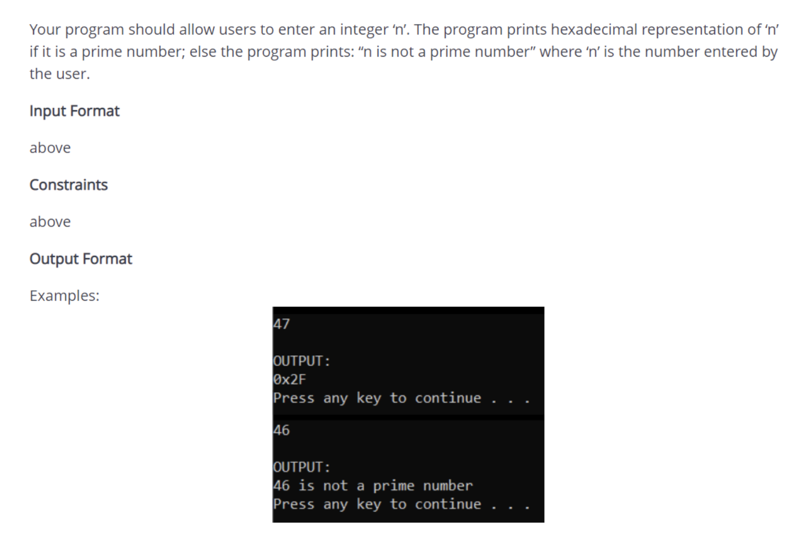](https://user-images.githubusercontent.com/29374426/179382477-ebc96ec3-4b2b-49f9-bc46-b30b1ffdd408.png)

#include <stdio.h>

#include <stdlib.h>

#include <string.h>

#include <math.h>

#include <ctype.h>

int checkprime(int n)

{

int i;

if (n < 2)

return 0;

for (i = 2; i <= sqrt(n); i++)

if (n % i == 0)

return 0;

return 1;

}

int main()

{

system("cls");

// INPUT - @STUDENT:ADD YOUR CODE FOR INPUT HERE:

int n;

scanf("%d", &n);

// Fixed Do not edit anything here.

printf("OUTPUT:\n");

//@STUDENT: WRITE YOUR OUTPUT HERE:

if (checkprime(n))

{

printf("0x%X", n);

}

else

{

printf("%d is not a prime number", n);

}

//--FIXED PART - DO NOT EDIT ANY THINGS HERE

printf("\n");

system("pause");

return (0);